Stage 1 -one week green - 1a-1c Building the Main menu and having the backgrounds set up

Stage 2-4 days blue 1-d-1e Finishing the menu and implementing a settings to change things for the user to have more agency

Stage 3- 1 week add a gui

Work on the GUI For the game and make the assets that are needed and ready available

Stage 4- 1 week red 2a 2-c have a working game with waves that come in and defences

Stage 5 1 week 2d-2e Having power and teamups to make the game unique and have a new feel

Stage 6-3a-3b Create the multiplayer for local and online

Stage 7-add in any additional ideas that are in the unlikely section

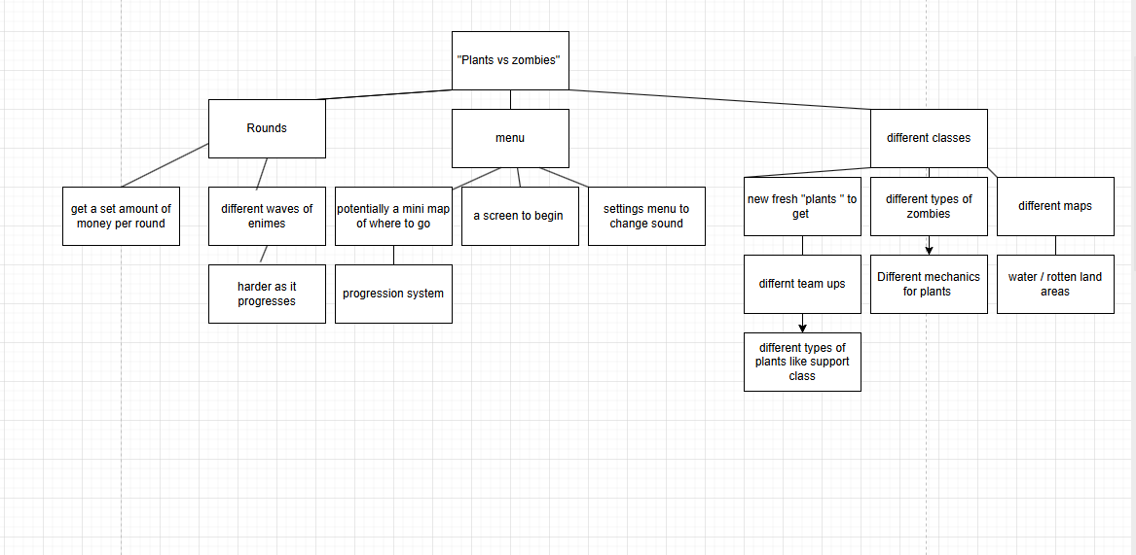

**

**Data Dictionary**

|  |  |  |
| --- | --- | --- |
| Variable | Type | Description |
|  |  |  |
|  |  |  |
|  |  |  |
|  |  |  |
|  |  |  |
|  |  |  |

100011 1/1

Initialize D so it can be used o line 4 and be given a value to hold 2/2

c) concatenates d and x 2/2

d)Input

result =“”

For pos = 1

If “A”

Result = result + “0”

Elif “B”

Result = result + “11”

Else” C”

result = result+ “100”

END FOR 3/7

Need d